Experts from twelve African countries discuss joint project on nuclear security, take part in radiological emergency response exercise and mark the ISTC Special Day at EXPO 2017 in Astana
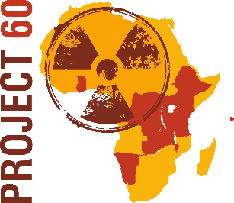
12 June 2017, Astana. National radiological and nuclear (RN) experts from 12 African countries will meet in Astana this week to discuss progress in the implementation of their joint project Support to the EU CBRN Center of Excellence for Central and Eastern Africa in Nuclear Security (Project 60). Representing the Steering Committee of the project, the experts will share observations on the P 60 initial activities, including the submission of Letters of expression of interest from their national authorities. The Steering Committee members will also deliberate timing and preference to host training courses, table top and field exercises, the schedule of expert visits and the need of public advocacy and awareness raising events in the P 60 participating countries: Burundi, Democratic Republic of Congo, Ethiopia, Ghana, Kenya, Malawi, Rwanda, The Seychelles, Tanzania, Uganda, Zambia and Namibia. The national stakeholders’ interaction and their experiences with the elaboration of National Radiological and Nuclear Response Plans is also part of the meeting’s agenda.
Project 60 Steering Committee is convened by the project’s implementing partner - the International Science and Technology Center (ISTC) in Astana. Representatives of the European Commission Directorate-General for International Cooperation and Development (DG DEVCO), the European Commission Joint Research Centre (JRC) and of the AESA On-Site Technical Assistance (OSA) will also participate in the meeting. All international partners and the representatives of the P-60 participating countries that are member states of the South African Development Community will discuss at the fringes of the Steering Committee meeting the progress of a parallel project MC 5.01/15B with complementary activities - Support to Southern African States in Nuclear Safety and Safeguards.
Project 60 seeks to strengthen and harmonize the nuclear regulatory frameworks in the participating countries, to enhance their nuclear safety and security and to support their efforts to fulfill the international safeguards obligations they have assumed under multilateral treaties and conventions. Launched in late February in Nairobi, Project 60 has so far made its inception steps: project countries have shared priorities of their national RN plans and discussed initial ideas how to better address the challenges of managing RN sources in all industrial and medical domains, and of ensuring safe trans-border transportation of RN materials. In line with the agreed goal to make all possible strives in raising public awareness about the importance of nuclear security and safety issues, Project 60 has partnered with the Kenyan Young Generation in Nuclear and supported the Inaugural African Youth Nuclear Summit. In addition, the project has facilitated initial contacts between the Youth Nuclear Association of Kazakhstan and the international Youth Nuclear Congress. In continuation of P 60 public advocacy activities, the Steering Committee members will join several events taking place along the EXPO 2017 in Astana.
The experts from Project 60 participating countries will take part in the Regional radiological emergency response Table Top Exercise SUNKAR, organized by the European Commission and the International Science and Technology Center with support from the EU CBRN Center of Excellence for Central Asia and the Vienna-based engineering and management consultancy ENCO. The representatives of East and

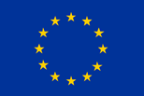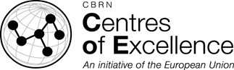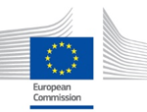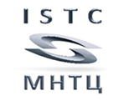
Central Africa will assume the role of participants or observers in the simulation of a decision making process on the selection and implementation of emergency protection and recovery measures upon a sealed high activity source being stolen. The objective and scope of the SUNKAR exercise are similar to the trainings, tabletop and field exercises that will be organized in the next 24 months by the P 60 participating countries. By honing their knowledge and skills in emergency radiological response activities, the P 60 experts will be able to plan, implement and coordinate similar simulations and will be better prepared to act in real time emergencies.
During their visit to Astana, the Project 60 RN experts will take part in the International conference on the topic Future Energy and Technologies, convened to celebrate the 20th anniversary of the ISTC. The head of the Secretariat of the Eastern and Central Africa EU CBRN Center of Excellence Joseph Maina, together with speakers and guests from over 30 countries, will address the ISTC Special Day at EXPO 2017. The experts from Central and Eastern Africa will visit the EXPO exhibition site and will pay special attention to the radiation detection instruments, displayed in various pavilion, as well as to a model of Kazakhstan’s thermonuclear material testing reactor, the most recent addition to the worldwide Tokamak family.

For more information about Project 60, visit: www.istc.int.
The project Support to the European Union Chemical, Biological, Radiological and Nuclear Center of Excellence (EU CBRN CoE) for Eastern and Central Africa in Nuclear Security is funded by the EU Instrument contributing to Peace and Security and is part of the CBRN Centers of Excellence initiative of the European Union. The ISTC will be implementing this project in parallel with a similar initiative, namely Support to Southern African States in Nuclear Safety and Safeguards under the EU Instrument for Nuclear Safety Cooperation. Conceived as complementary to each other, the two initiatives illustrate the internationally recommended “Triple S” approach addressing simultaneously the nuclear safety, safeguards and security issues.

