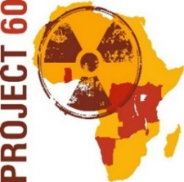
PROJECT 60: Spreading the Culture of Nuclear Safety and Security in Central and Eastern Africa
Prof. Geoffrey Emi-Reynolds, a member of the Ghana National CBRN Team and former director general of Ghana Atomic Energy Commission, participated in April at an event, convened by the EU Delegation to the United Nations in Geneva and dedicated to the management of the full-life cycle of radioactive sources. In line with the event’s main theme "Benefits of the NPT: international cooperation in radioactive sources throughout their lifecycle", prof. Emy-Reynolds spoke about Ghana’s positive experiences from participating in the EU CBRN Centres of Excellence Initiative and in particular in the Project 60. He participated at the panel discussion together with representatives from the European Commission’s Joint Research Center, the EU Delegation to the UN in Vienna, the IAEA, and the French Nuclear Safety Authority.
The side event took place during the second session of the Preparatory Committee for the 2020 Review Conference of the Parties to the Treaty on the Non-Proliferation of Nuclear Weapons.
Project 60 featured in Geneva during the preparations for the 2020 Review Conference of the Parties to the NPT
At mid-point of its implementation, Project 60 reaches out to more experts in nuclear safety and security in all eleven participating countries-members of the EU CBRN Center of Excellence in Eastern and Central Africa. As the project enters a most decisive and dynamic phase, its Steering Committee recently met to discuss progress and to plan future steps.
Project 60 kicked off 2018 activities at a meeting in Addis Ababa
Thirty-two national representatives from the P 60 participating countries gathered for a technical meeting and a training in Addis Ababa in February. The meeting introduced the project’s implementation team, the planned tasks and schedule of activities. Representatives from ISTC and EC DEVCO provided overview and details about the regional and thematic context that shapes the specific project’s goals and activities.
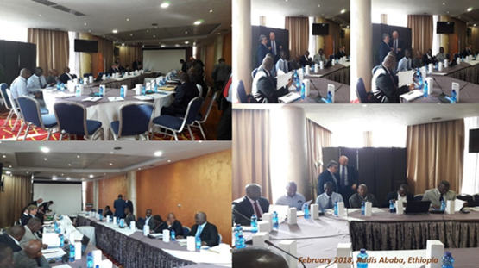
Throughout the exchange of views, the meeting’s participants touched on the existing legislative frameworks, inventory and regulatory control of RN material and the national EPR plans (emergency plans and contingency plans) for RN incidents. A three-day training workshop followed the technical kicks-off meeting. A team of international experts led the workshop, themed “Cradle to grave” control of radiological material. They introduced the IAEA Code of Conduct and other IAEA standards and guidance, as well as the EU directives and best practices in the EU on control of radioactive sources. The experts presented the key elements of the national policies and strategies, and the legislative and regulatory frameworks and structures for radioactive sources including safety and security provisions. The workshop covered as well all aspects related to import, export, repatriation and safe transportation of sources. The participating countries highlighted their national arrangements and experience with control of radioactive sources, and elaborated on the national and regional challenges related with radioactive sources.

A workshop about response plans for RN incidents took place in Kenya recently, following in the footsteps of the workshop “Cradle to grave” control of radiological material (Addis Ababa, February 2018).
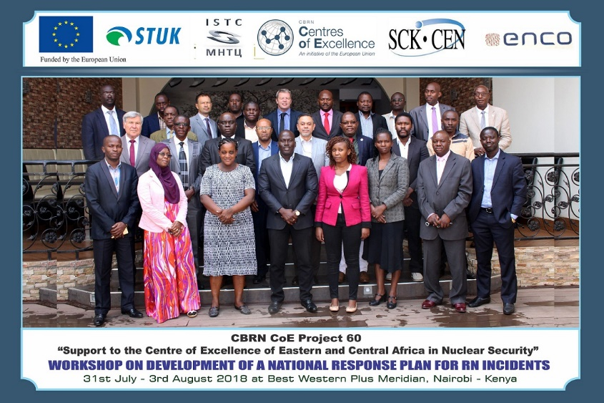
The upcoming regional workshop on inventory, accountancy and control of radioactive material, co-hosted by the Tanzania Atomic Energy Commission (August 2018), is focused on tools for enhancing the information management in the regulatory authority.
Expert missions to project countries aim to prepare country specific reports on management of radioactive sources, as well as an assessment of the specific equipment needs of the participating countries, a question of primary importance to them. Initial review took place during expert missions to examine the national capabilities to address safe and secure handling and storage of radiological sources, and also orphan sources and seized materials in: Rwanda (19-21 April 2018), Kenya (21-24 May 2018), Ethiopia (11-15 June 2018), Seychelles (13-14 June 2018), Tanzania (26-29 June 2018), Uganda (2- 5 July 2018), Malawi (during the week 9-13 July 2018), Burundi (16-17 July 2018), DRC (18-20 July 2018), Ghana (23-26 July 2018).
“A local physician warned the law enforcement organization: he examined several patients today, who seemed to be suffering from radiation syndrome: drop of blood cells, vomiting… All patients had one feature in common: they all went to the same public place. It was suspected that a radioactive source was present in this public place, therefore the area was evacuated and the entries have been cordoned off. The aim is thus to search whether radioactive sources are present in the public place and if radioactive sources would be found, to identify, characterize and recover them.”
Field exercises form an important part of Project 60 activities. This is the scenario received by representatives from respective national radiation protection authorities and nuclear safety -responsible institutions who are preparing to partake in field exercises in Arusha, Tanzania and in Addis Ababa, Ethiopia, on the topic: “Radioactive source identification and recovery”.
Members of the Project’s Steering Committee decided to plan field exercises and table-top exercises in various formats in a broad spectrum of topics.
“Scenario: HIDDEN RADIOLOGICAL EXPOSURE DEVICE”
Project 60 Steering Committee considers Next Steps
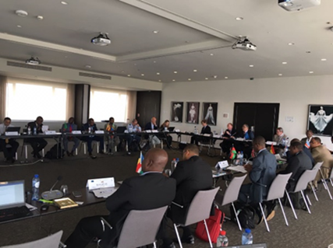
A regular meeting of Project 60 Steering Committee took place in Brussels on 22 June 2018. National Focal Points and radiological and nuclear (RN) experts from P-60 participating countries were joined by representatives of the project’s managing and implementing partners: the European Commission’s DEVCO and Joint Research Center, UNICRI, ISTC, the Secretariat of the CBRN ECA CoE, as well as by representatives of the Consortium, contracted to carry out the project’s trainings, expert missions, consultancies and country reports. The Steering Committee ● took note of the decision to extend the duration of the implementation period of Project 60 until the end of March 2020; ● welcomed and approved the inclusion of Ethiopia as a P-60 participating state; ● decided to discuss and adopt Terms of Reference for its functions; ● underlined the importance of the delivery of the needed equipment to the participating countries and decided to continue to examine the possibilities in that regard; ● took note of the progress reports by ISTC and by the Consortium, led by ENCO and provided guidance on further reporting and activities; ● accepted the proposal by Zambia to host a public awareness event under Project 60.

Public outreach
Project 60 website was designed with a public (external) and a forum (internal, members only) interface. It contains general information about the EU CBRN CoE Initiative and the EU CBRN CoE for ECA. The website hosts several sections such as: About Project 60, Participating countries, News, Resources and documents. It also currently presents information about the related project MC 5.01/15B with complementary activities - Support to Southern African States in Nuclear Safety and Safeguards. The content is recurrently updated and additional information and documents are regularly up-loaded. In addition to the basic information about the project, its goals and objectives, the website offers press releases on project activities, leaflet, posters, testimonials, short interviews with the national representatives, as well as photos and a video story about the Regional Table Top Exercise Sunkar. Currently, documents that are to be shared amongst the members of the Steering Committee are up-loaded on the forum (members only) part of the website.

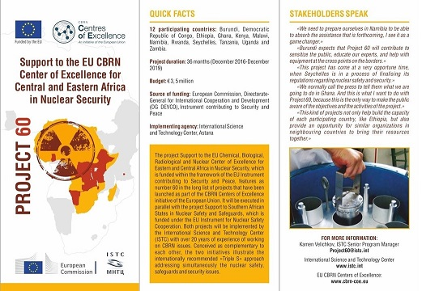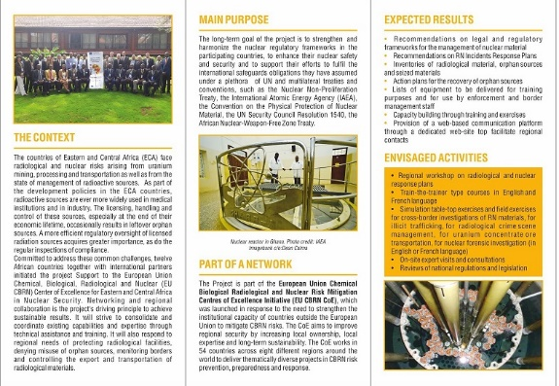

Project 60 “Support to the CBRN Centre of Excellence of Eastern and Central Africa in Nuclear Security” was officially launched in Nairobi, Kenya, in February 2017. The project is implemented by the International Science and Technology Center (ISTC). The project’s sub-contractor is an international consortium between ENCO (a Vienna-based engineering and management consultancy with expertise in the field of nuclear safety, nuclear operation and technical support), STUK (The Radiation and Nuclear Safety Authority tasked with nuclear safety and radiation monitoring in Finland), and SCK-SEN (the Belgian Nuclear Research Centre).
The following countries, belonging to the EU CBRN Eastern and Central Africa (ECA) Centre of Excellence, participate in Project 60: Burundi, Democratic Republic of Congo, Ethiopia, Ghana, Kenya, Malawi, Rwanda, the Seychelles, Tanzania, Uganda, and Zambia.
© August 2018

